The perimeter is distance you need to travel around a shape .
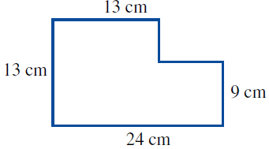
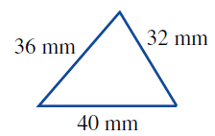
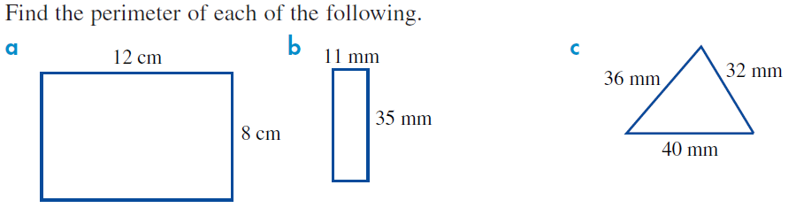

On circles the perimeter is called the circumference and is found using a formula. Circumference =2$×π×radius$
Find the perimeter for the following
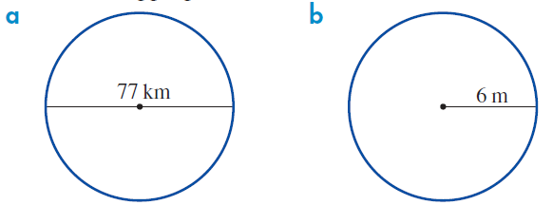

Area is the floor space a 2-dimensional shape has inside it. A good example is to think about how much carpet would you need to cover a floor.
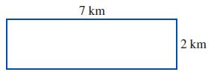
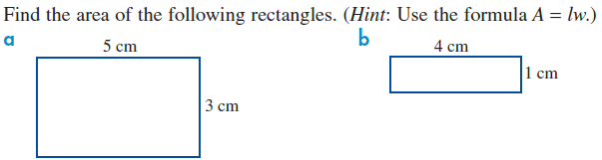

(Hint: Use the formula $Area= \frac{1}{2} (base ×height)$
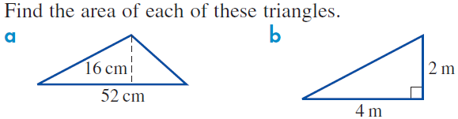

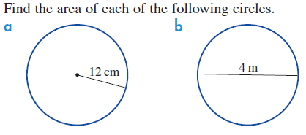
(Hint: Use the formula $Area= π×{radius}^{2}$

For complex (compound) shapes we need to break them up into smaller pieces, find the area of each piece and add them together.
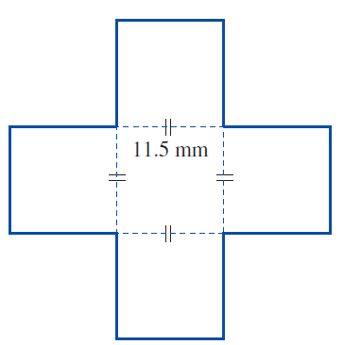
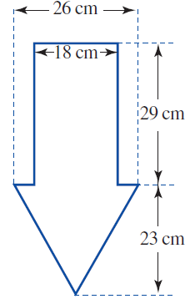
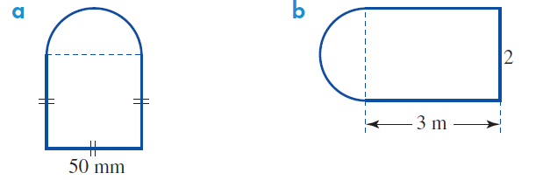

The surface area of a 3dimensional object is the area of each side of a shape added together (ie how much area would I need to paint to cover the outside surface of the object ).
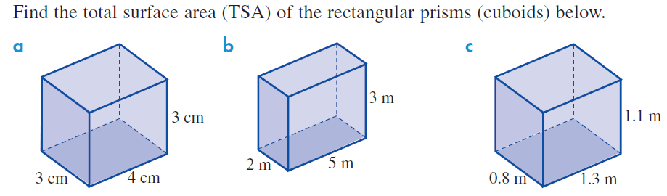

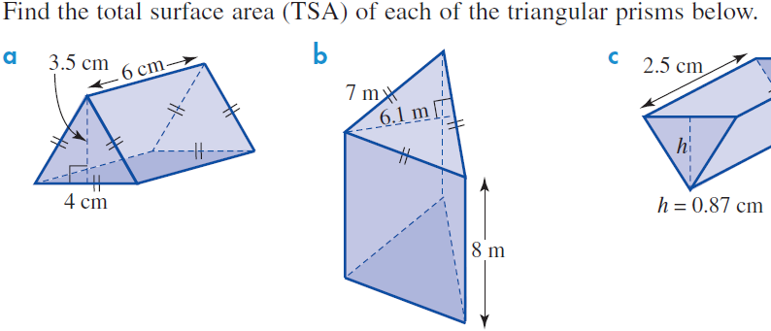

Find the total surface area of the following cylinders
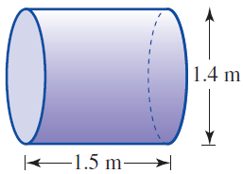
(Hint: $Area=2×π×{radius}^{2}+2×π×radius×height$)
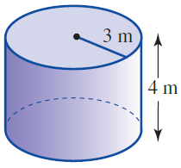


Remember when dealing with compound prisms, you will need to break down the compound shape into smaller pieces to find the area of the face. Also, the more sides the face surface has, the more rectangles you will have connecting the 2 faces
